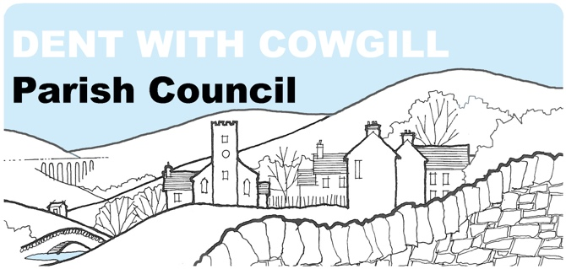

Dent with Cowgill Parish Council Planning Committee
Terms of Reference

- Overall Function – The purpose of the Planning Committee is;
  - to examine all planning applications to which the Parish Council is a consultee and to make recommendations to the council on action to be taken
  - to make recommendations for planning policies by which the Parish Council wishes to judge all applications
  - to consider any policy consultations made by the Primary Planning Authority

- Relationship to the Parish Council
The Planning Committee is a committee of Dent with Cowgill Parish Council. The Parish Council acts as a consultee on all planning applications within the parish and can make comments and recommendations to the Primary Planning Authority.

- Meetings
  - Meetings shall be held via video conference once per month. The public will be invited to attend and an agenda will be published in advance and minutes taken, in accordance with Parish Council procedures
  - The Parish Council shall receive the minutes of each meeting

- Membership and Quorum
  - The committee shall consist of five members. Of these, one shall be the Chair or Vice Chair of the Parish Council and four shall be members of the Parish Council.
  - The quorum for the committee shall be three members.
  - In the event that a quorum cannot be made due to apologies being received, each member of the committee shall be entitled to nominate a substitute councillor to attend on his/her behalf. Such nomination must be received with the written apologies of the councillor who is unable to attend.

- Chairperson
  - The Chairperson will be elected at the first meeting held after the Annual Parish Council meeting in May each year.
- Specific Functions and Powers – The committee shall be responsible for;
  - Examining each planning application as advised by the Primary Planning Authority
  - Making comments and recommendations to the Primary Planning Authority
  - Devising policies by which all applications should be judged
  - Making representations to the Primary Planning Authority on any consultations it may undertake
  - The Parish Council has devolved its powers as a consultee to this committee in accordance with Local Government Act 1972 Sec.101.
  - The Parish Council has ordered that this committee may NOT devolve its powers to any sub-committee or an officer of the council.

- Finance
  - The committee shall be authorised to spend up to £500 in each financial year without reference to the full Parish Council.
  - The committee shall conduct its financial affairs in accordance with the legislation that governs Parish Council procedures
  - The committee may seek additional money for specific projects by applying for grants and by fundraising. Decisions about how money is raised in this way, is to be made by the committee

- Support
  - The Clerk to the Parish Council shall act as the clerk to the committee

- Review
  - The committee shall report on its work at the full Parish Council meeting following each committee meeting and to the Parish Council’s Annual Meeting each March

Adopted by the committee on:………………………..
Signed:………………………………………………………….
Chair to the Committee

