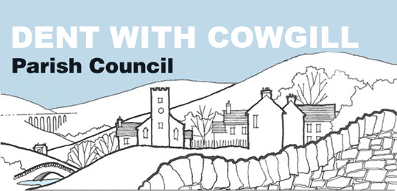

Dent with Cowgill Parish Council Playing Field Committee
Terms of Reference

- Overall Function – The purpose of the Playing Field Committee is;
  - to manage the upkeep, maintenance and use of the playing field and pavilion
  - to administer the annual budget allocation
  - to make recommendations for the future development of the playing field and pavilion

- Relationship to the Parish Council
The Playing Field Committee is a committee of Dent with Cowgill Parish Council. The Parish Council is the owner of the playing field and has ultimate responsibility for it, as well as the pavilion and maintenance equipment. The Parish Council also retains responsibility for keeping accounts and obtaining insurance, including public liability insurance, In order to manage the field most effectively, the Parish Council delegates to the Playing Field Committee the powers described in these terms of reference.

- Meetings
  - Meetings shall be held in public with agendas notified in advance and minutes taken, in accordance with Parish Council procedures
  - The Parish Council shall receive the minutes of each meeting

- Membership and Quorum
  - The committee shall consist of six members. Of these, one shall be the Chair to the Parish Council, one shall be a member of the Parish Council, one shall be elected by Sedbergh & Dent United Football Club. There will be three co-opted members
  - The quorum for the committee shall be three members, which must include at least one member of the Parish Council.
  - In the event that a quorum cannot be made due to apologies being received, each member of the committee shall be entitled to nominate a substitute councillor to attend on his/her behalf. Such nomination must be received with the written apologies of the councillor who is unable to attend.

- Chairperson
  - The Chairperson will be elected at the first meeting held after the Annual Parish Council meeting in May each year.

- Specific Functions and Powers – The committee shall be responsible for;
  - Maintaining the playing field to an acceptable standard for the use by Sedbergh & Dent Utd Football Club and the community
  - Maintaining the boundary walls and repairing them promptly when necessary
  - Maintaining the pavilion in good condition and carrying out any necessary repairs
  - Managing the use of the playing field and pavilion by any organisations and individuals
  - Formulating and implementing a charging policy for the use of the field by Sedbergh & Dent Utd Football Club and other users
  - Maintaining in safe working order all the equipment that is used for the upkeep of the field, and planning for and refinancing its replacement when needed
  - Carrying out risk assessments as appropriate
  - Advising the Parish Council on insurance requirements
  - Advising the Parish Council on the future development of the playing field and pavilion

- Finance
  - The committee shall be authorised to spend up to £500 without reference to the full Parish Council.
  - The committee shall be responsible for submitting annual budget proposals to the Parish Council, and administering the budget allocation
  - The committee shall conduct its financial affairs in accordance with the legislation that governs Parish Council procedures
  - The committee may seek additional money for specific projects by applying for grants and by fundraising. Decisions about how money raised in this way, is to be made by the committee

- Support
  - The Clerk to the Parish Council shall act as the clerk to the committee

- Review
  - The committee shall report on its work at the full Parish Council meeting following each committee meeting and to the Parish Council’s Annual Meeting each March

Adopted by the committee on:………………………..
Signed:………………………………………………………….
Chair to the Committee

