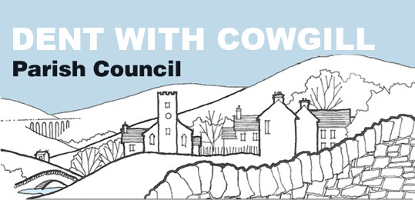

Dent with Cowgill Parish Council Amenities and Environment Committee
Terms of Reference

- Overall Function – The purpose of the Amenities and Environment Committee is;
  - to manage the upkeep, maintenance and replacement of all public amenities and the environment of the dale.
  - to administer the annual budget allocation for all public amenities and the environment
  - to make recommendations for the future development of the dale and its environment

- Relationship to the Parish Council
The Amenities and Environment Committee is a committee of Dent with Cowgill Parish Council. The maintenance and replacement of certain amenities and assets in the dale is the responsibility of the Parish Council. The Parish Council also retains responsibility for keeping accounts and obtaining insurance, including public liability insurance, In order to manage the amenities and assets most effectively, the Parish Council delegates to the Amenities and Environment Committee the powers described in these terms of reference.

- Meetings
  - Meetings shall be held in public with agendas notified in advance and minutes taken, in accordance with Parish Council procedures
  - The Parish Council shall receive the minutes of each meeting

- Membership and Quorum
  - The committee shall consist of five members. Of these, one shall be the Chair/Vice-Chair to the Parish Council, three shall be members of the Parish Council, one shall be the Clerk to the Parish Council who acts as Highways Steward Liaison.
  - The quorum for the committee shall be three members, which must include at least two members of the Parish Council.
  - In the event that a quorum cannot be made due to apologies being received, each member of the committee shall be entitled to nominate a substitute councillor to attend on his/her behalf. Such nomination must be received with the written apologies of the councillor who is unable to attend.

- Chairperson
  - The Chairperson will be elected at the first meeting held after the Annual Parish Council meeting in May each year.

- Specific Functions and Powers – The committee shall be responsible for;
  - Maintaining the Parish Council owned amenities and assets to an acceptable standard for the use by visitors to the dale and the community
  - Carrying out risk assessments as appropriate

  - Advising the Parish Council on insurance requirements
  - Advising the Parish Council on the future development of the dale

- Finance
  - The committee shall be authorised to spend up to £500 in each financial year without reference to the full Parish Council.
  - The committee shall be responsible for submitting annual budget proposals to the Parish Council, and administering the budget allocation
  - The committee shall conduct its financial affairs in accordance with the legislation that governs Parish Council procedures
  - The committee may seek additional money for specific projects by applying for grants and by fundraising. Decisions about how money raised in this way, is to be made by the committee

- Support
  - The Clerk to the Parish Council shall act as the clerk to the committee

- Review
  - The committee shall report on its work at the full Parish Council meeting following each committee meeting and to the Parish Council’s Annual Meeting each March

Adopted by the committee on:………………………..
Signed:………………………………………………………….
Chair to the Committee

