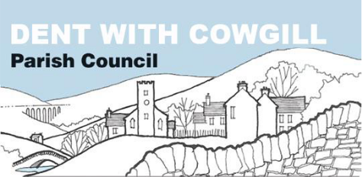

Retention of Documents Policy

Policy adopted on | 01 June 2020
Reviewed and approved on | 07 June 2021

DENT WITH COWGILL PARISH COUNCIL
RETENTION OF DOCUMENTS POLICY

Introduction
The Parish Council recognises that the efficient management of its records is necessary to comply with its legal and regulatory obligations and to contribute to the effective overall management of the Parish Council.
This document provides the policy framework through which this effective management can be achieved and audited. It covers:
Scope
Responsibilities
Retention Schedule
Disposal of records

Scope of the policy
This policy applies to all records created, received or maintained by the Parish Council in the course of carrying out its functions.
Records are defined as all those documents which facilitate the business carried out by the Parish Council and which are thereafter retained (for a set period) to provide evidence of its transactions or activities. These records may be created, received or maintained in hard copy or electronically. A small percentage of the Parish Council’s records will be selected for permanent preservation as part of the Council’s archives and for historical research.
Responsibilities
The Parish Council has a corporate responsibility to maintain its records and record management systems in accordance with the regulatory environment. The person with overall responsibility for the implementation of this policy is the Clerk to the Parish Council, and she/he is required to manage the Council’s records in such a way as to promote compliance with this policy so that information will be retrieved easily, appropriately and in a timely manner.
Retention Schedule
Under the Freedom of Information Act 2000, the Parish Council is required to maintain a retention schedule listing the record series which it creates in the course of its business. The retention schedule lays down the length of time which the record needs to be retained and the action which should be taken when it is of no further administrative use. The Clerk is expected to manage the current record keeping systems using the retention schedule and to take account of the different retention periods when creating new record keeping systems.
Disposal procedures:
All documents that are no longer required for administrative reasons should be shredded and disposed of.

Retention of Documents Schedule
This retention schedule refers to record series regardless of the media in which they are stored.
Document Minimum Retention Reason
Minute Books Indefinite Archive
Annual Accounts Indefinite Archive
Annual Return Indefinite Archive
Bank statements 7 years Audit/management
Cheque book stubs Last completed Audit Management
Paying in books Last completed Audit Management
Quotations 7 years Audit
Paid invoices 7 years Audit/VAT
VAT records 7 years Audit/VAT
Salary records 7 years Audit
Tax & NI records 7 years Audit
Insurance policies Whilst valid Audit
Cert of Employers Liability 40 years Audit/legal
Cert of public liability 40 years Audit/legal
Assets register Indefinite Audit
Deeds, leases Indefinite Audit
Declarations of acceptance Term of Office + 1 year Management
Members register of interests’ book Term of office + 1 Management
Complaints 1 year Management
General information 3 months Management
Routine correspondence & e-mails 6 months Management
Planning Applications
All planning applications and relevant decision notices are available at Yorkshire Dales National Park Authority. There is no requirement to retain duplicates locally. All Parish Council recommendations in connection with these applications are recorded in the Authority minutes and are retained indefinitely. Correspondence received in connection with applications will be retained as stated in the above schedule.

