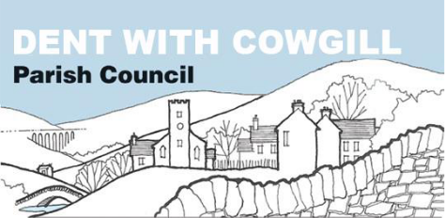

Housing Policy

Adopted on | 21 September 2020
Reviewed and approved on

Dent with Cowgill Parish Council
Housing Policy

Dent with Cowgill Parish Council works to shape the environment of Dentdale by commenting, as a statutory consultee, on all planning applications in its area and by working co-operatively with Yorkshire Dales National Park Authority which is the decision-making authority on planning matters.
One of the stated objectives of the council is to support the School and Pre-School in the village in order to continue to attract families to the dale.
Through its policy on Second Homes and Holiday Let properties, the council has been seeking to provide opportunities for families to live and work in the dale but recognises that there is more that can be done.
This policy aims to set out the council’s policy on providing new, social and affordable housing to attract and keep young families in the dale, thus protecting the future of the school and pre-school. The policy has been written with the YDNPA Local Plan 2015-2030 in mind.
Specifically, Dent with Cowgill Parish Council will
- seek to maintain the unique character and feel of Dentdale, particularly in the Conservation Area, by opposing inappropriate design or development. Housing development should be sympathetic to the existing street scene
- seek to identify land that could be used for small developments of affordable housing in addition to the two areas already allocated for this purpose by YDNPA
- seek to increase the number of social housing properties in the dale
- seek to ensure that any new developments contain a mix of property types including accessible and single storey properties for disabled residents, starter homes and homes for families
- seek to ensure that a range of affordable housing is included in future housing developments, enabling Dentdale to be home to people of all ages. The Council expects Yorkshire Dales National Park Authority to ensure that 50% of developments of 11 houses or more will be affordable homes, as defined in the Local Plan 2015-2030
- look into all methods of providing social and affordable housing, including Community Led Housing Plans

