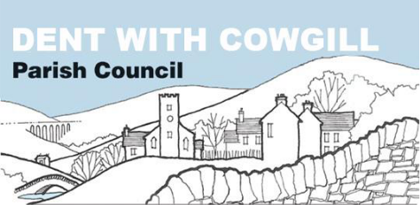

Holiday Let Planning Policy

Policy adopted on | 04 March 2019
Reviewed and approved on | 07 June 2021

Dent with Cowgill Parish Council - Planning Policy regarding holiday lets

In respect of applications for planning, the Parish Council will not support any applications for holiday lets (that is those properties which are let on a short-term basis for profit) in Dentdale as it believes that the current number of such properties is excessive.
The number of holiday lets is reducing the number of opportunities for affordable and local occupancy dwellings (i.e. those that are permanently occupied by residents of the dale) which will eventually result in a reduction in the permanent population of the dale and the demise of the primary school and the few businesses that remain.
The basis of this policy is the preservation of the community in Dent and takes into account the following policies from the Yorkshire Dales National Park Local Plan:
SP1
Development will be deemed to be unsustainable if it would reduce:
- the health and well-being of local communities;
- the diversity, quality and local distinctiveness of the natural and cultural landscape, wildlife, historic environment or other special qualities of the National
Park

- the strength, diversity or vitality of the local economy;
- the supply of housing to meet local needs;
- access to local services and community facilities.
SP2
Development will be permitted that furthers the statutory National Park purposes of:
- conserving and enhancing natural beauty, wildlife and cultural heritage;
- promoting opportunities for the understanding and enjoyment of the special qualities of the National Park by the public.

